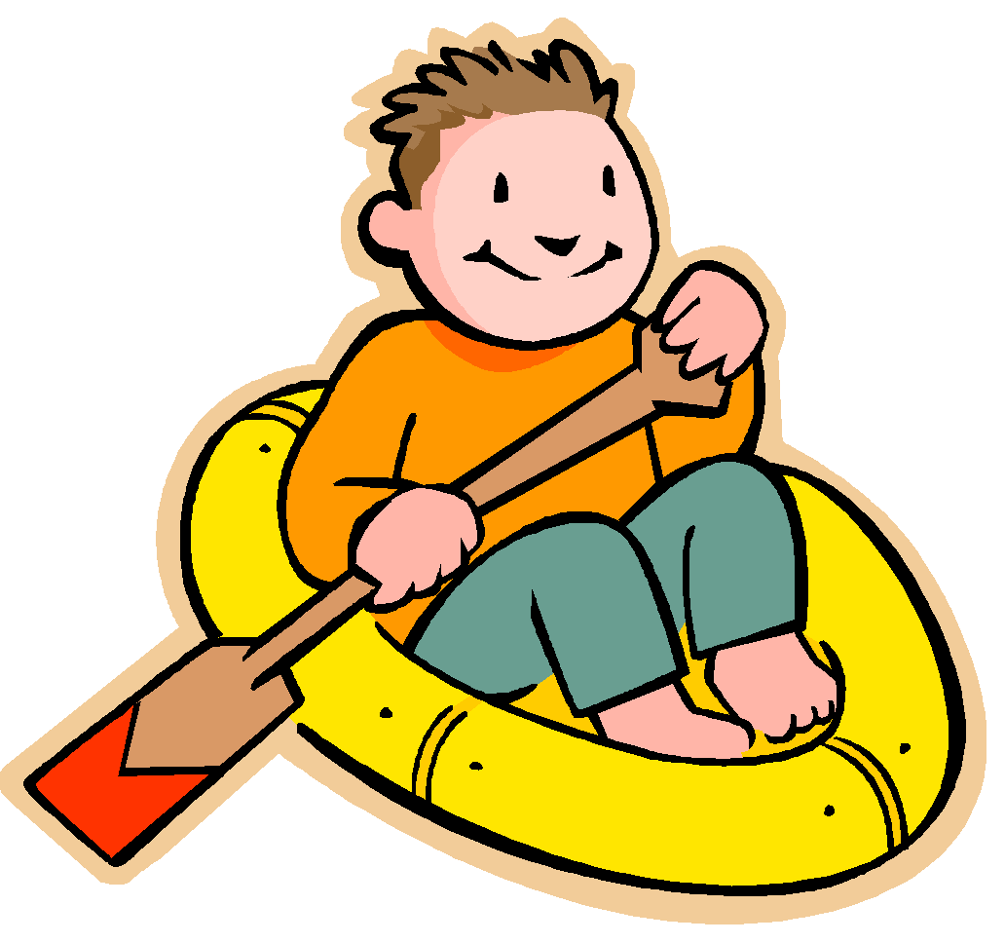
RAFT Assignment

Name: ________________________________ Date: _____________ Period: ____________

Unit/Theme: ________ Language/Level: _______________________________

Role | Audience | Format | Topic
Convergent Boundary | Convection Currents | Song | How the plates move around the Earth?
Divergent Boundary | Tectonic Plates | Letter | How is the theory of Plate Tectonics supported?
Transform Boundary | People of Earth | News Article | What kinds of geological formations are created at certain faults?
Alfred Wegener |  | Poem
Volcano |  | Comic Strip

